MacGraw Hideaway

“MacGraw Hideaway” is an independent product published under the DRAW STEEL Creator License and is not affiliated with MCDM Productions, LLC. DRAW STEEL © 2024 MCDM Productions, LLC.

MacGraw Hideaway © 2025 Look Out Behind You Studios LLC
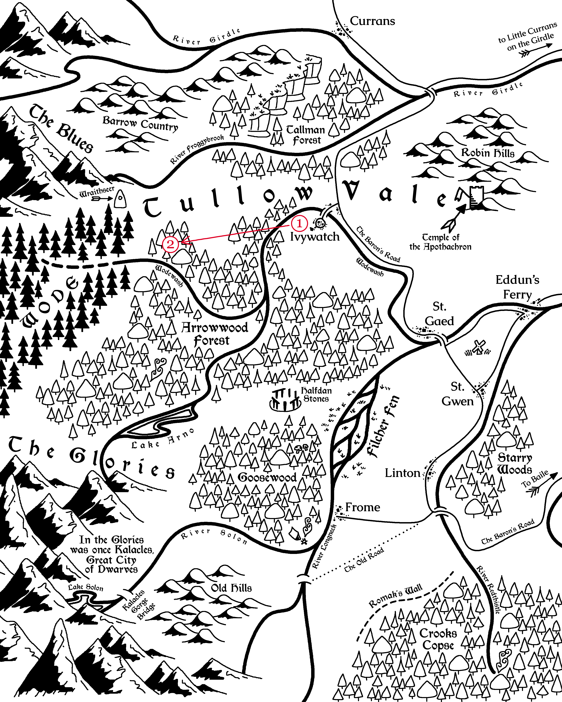
Marked in red are the locations of each part of the adventure.

MacGraw Hideaway
MacGraw Hideaway is an adventure set in Vasloria, a woody, humid, and vaguely Europe-like region of Orden. The adventure is designed for two to seven 1st-level heroes and grants between 2 and 6 Victories.

MacGraw Boss, Blarg
The lizardfolk necromancer Deatheye Yslansh wants to summon the Avatar of Torment, Excrucior Interfectus to wipe out Tullow Vale and leave behind a wasteland of death for her to lord over.

Adventure Hook
MacGraw Hideaway assumes the following adventure hook.
Trademark Violation: The last few weeks, goblins have been attacking merchants along the Baron’s Road in Tallman Forest and kidnapping victims. The Company of Cordwainers have been hit the hardest by the attacks, but were content to let the local authorities handle it in their own time, until the goblins gained the moniker of the “MacGraw Tribe.” Tybald MacGraw, the guildmaster of the company, doesn’t like sharing, least of all his name.
The company sends a contact to the heroes in Currans with a job: eradicate the creatures from their hole.

Scenes
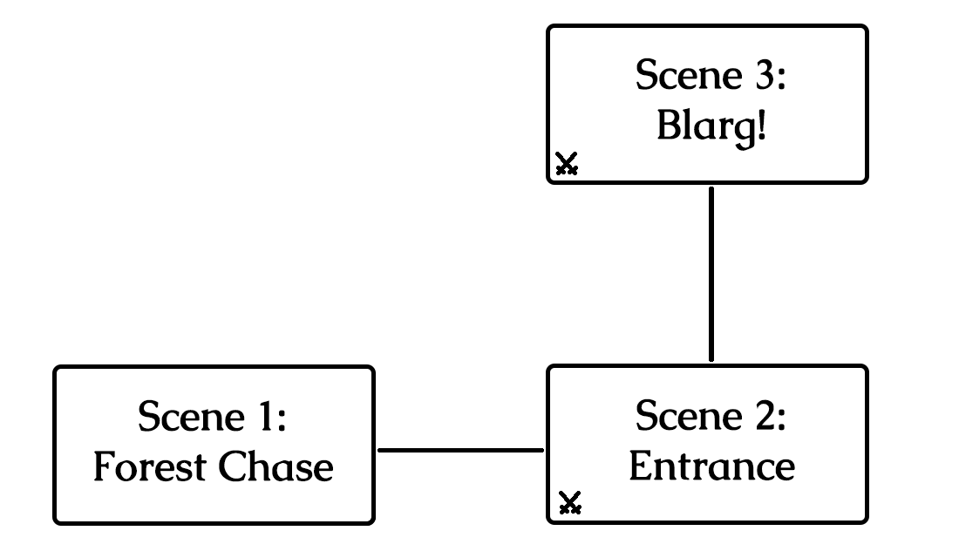
The scenes and how they connect in the adventure.

The contact in Currans told you very few details, but ultimately the job was very simple: eradicate the goblins terrorizing Tallman Forest from their hole.
And so you set out and here you are, on the Baron’s Road heading south from Currans.
Boxed, italicized text like this is meant to be read aloud to your players!
Dir. Note: Director notes like this contain information the players should not be told!
Take a moment to do the following:
- Encourage the players to introduce their heroes if they haven’t already.
- Each of the heroes are each well-known in some region, if not this one. Ask each player what the title is of the most popular bard’s song about their hero’s exploits.
- Ask the players how their heroes each spend evenings in camp while on the road and which of their senses they most rely on while searching for goblins.
Every tree in Tallman Forest seems to hide an extra shadow. Every bird’s song sounds a little suspicious.
Suddenly, a scream from a bit further down the road interrupts your focus, and then hones it.
You were just a step to late! As you round the corner, you see the last goblin hit a victim over the head and haul their unconscious body into the forest away from their burning caravan.
Goblins are well known for their ambushes. No normal person would willingly follow a tribe through their home turf.

Scene 1: Forest Chase
Following Baxter’s race against the Hawklords to the keep will be a montage test. The failure limit is 2 and the success limit is equal to the number of heroes (minimum 3, maximum 5).
The challenges of the montage test align with obstacles along the way to the keep.
Following Baxter
- A multi-story tavern has collapsed, covering the road with a heap of splintered timbers and rubble that would be insurmountable for a normal person.
- The main road ends at the market square and splits into many alleys and narrow streets. It’s not obvious which path is most direct to the keep.
- A raging fire’s roar drowns out Baxter’s barking, making it harder to tell which direction he’s determined is quickest to the keep.
- As you pass some corpses, a lizardfolk you thought dead claws at you, gashing your leg. You can’t run with the wound unattended.
- Bodies and mud clog up the street passing the collapsed chapel. Baxter nimbly navigates the mess, but you’re too big to follow in the same way.

If a hero takes on a challenge with an intrigue or lore skill and succeeds, they find a lizardfolk corpse clutching a rosary that doesn’t appear to be theirs.
The first hero to get a tier 3 outcome finds a sealed letter among the rubble addressed to “Jacqueline.”

Deflect the Orbs!
The heroes arrive at the keep just as the Hawklords begin their second assault of Ivywatch, dropping iron orbs on the keep. The party attempts an Agility Group Test to deflect the bombardment.

The heroes’ successes and failures in the montage test determine the difficulty of the Group Test and the consequences of success or failure.
Total Failure
The heroes attempt a Hard Agility Group Test to deflect the iron orbs.
- Fewer than half succeed: The keep’s walls and bridge are destroyed. The citizens are far more vulnerable now. The heroes are exhausted from the chase and the bombardment. In Scene 3, all heroes begin the encounter slowed (EoT).
- Half or more succeed: The hawklords that descend cry out to the heroes “Are you the bastards that led the lizards to attack?!” The townsfolk glare at the hawklords with hate.

Partial Success
The heroes earn 1 Victory and attempt a Medium Agility Group Test to deflect the iron orbs.
- Fewer than half succeed: The keep’s walls and bridge are destroyed. The citizens are far more vulnerable now.
- Half or more succeed: The hawklords that descend cry out to the heroes “Are you the bastards that led the lizards to attack?!” The townsfolk glare at the hawklords with hate.

Total Success
The heroes earn 1 Victory and attempt a Medium Agility Group Test to deflect the iron orbs.
- Fewer than half succeed: The keep’s walls are destroyed. The keep is much less defensible now.
- Half or more succeed: The hawklords that descend cry out to the heroes “Are you the bastards that led the lizards to attack?!” but the townsfolk throw rocks at them. In Scene 3, all enemies begin the encounter slowed (EoT).

Scene 2: Entrance
The hawklords descend upon the keep, both against the heroes and among the townsfolk!
“We know the Jewel of Redemption is here, we know you have hidden it! Give it to us now and no one will get hurt!”
A stoic woman in leather armor walks forward and unsheathes a hand-and-a-half sword.
“Come and take it! Strike down a real lord and earn your jewel! If you can!”

Draw Steel! “Entrance”
The Hawklords attempt to kill Lord Thorton.
Earn 1 Victory and the pinfeather of a giant hawk for ending the immediate threat of the Hawklords and preventing them from killing the lord and any townsfolk.

Height
- Each ledge is 2 squares tall.
- The upper floor and battlements are 4 squares tall.

Encounter
If the gate was destroyed in the group test, use the “GATE FALLEN” map variant, otherwise use the “GATE STANDING” map variant. Likewise, if the bridge was destroyed, put the “BRIDGE FALLEN” prop on the map, otherwise put the “BRIDGE STANDING” prop on the map.
The heroes begin in the box marked “START.” The positions of all enemies are immediately detectable.

Party Size | Location | Malice – Humans  Enemy Forces:
2 | Bridge  Keep | Squad A: 4 Guards (m)  Squad B: 4 Guards (m)  Squad C: 1 Knave  + 1 Giant Hawk (mt)
4 | Bridge  Keep | Squad A: 6 Guards (m)  Squad B: 6 Guards (m)  Squad C: 1 Knave  + 1 Giant Hawk (mt)  Squadless: 2 Brawlers
* for unlisted party sizes, add 1 Trickshot (Bridge – Squadless) per extra member over a listed party size.

Tactics

The knave and its hawk in Squad B will spend their turn trying attacking Lord Thorton. The guards and brawlers will try to reach townsfolk, grab them, and then attack them and use them as meat shields. The trickshots can focus fire on the heroes (or the Lord if you want to be mean) from high ground.

Scene 3: The Hawklords
The hawklords descend upon the keep, both against the heroes and among the townsfolk!
“We know the Jewel of Redemption is here, we know you have hidden it! Give it to us now and no one will get hurt!”
A stoic woman in leather armor walks forward and unsheathes a hand-and-a-half sword.
“Come and take it! Strike down a real lord and earn your jewel! If you can!”

Draw Steel! “The Hawklords”
The Hawklords attempt to kill Lord Thorton.
Earn 1 Victory and the pinfeather of a giant hawk for ending the immediate threat of the Hawklords and preventing them from killing the lord and any townsfolk.

Height
- Each ledge is 2 squares tall.
- The upper floor and battlements are 4 squares tall.

Encounter
If the gate was destroyed in the group test, use the “GATE FALLEN” map variant, otherwise use the “GATE STANDING” map variant. Likewise, if the bridge was destroyed, put the “BRIDGE FALLEN” prop on the map, otherwise put the “BRIDGE STANDING” prop on the map.
The heroes begin in the box marked “START.” The positions of all enemies are immediately detectable.

The heroes gain a temporary alliance with the level 1 retainer “Gwennyl Thorton” during this encounter.
Dir. Note: If Lord Thorton is close to death, her steward (an older polder) will throw himself in the way of the final blow, allowing Thorton a decisive strike on her attacker.

Party Size | Location | Malice – Humans  Enemy Forces:
2 | Bridge  Keep | Squad A: 4 Guards (m)  Squad B: 4 Guards (m)  Squad C: 1 Knave  + 1 Giant Hawk (mt)
4 | Bridge  Keep | Squad A: 6 Guards (m)  Squad B: 6 Guards (m)  Squad C: 1 Knave  + 1 Giant Hawk (mt)  Squadless: 2 Brawlers
* for unlisted party sizes, add 1 Trickshot (Bridge – Squadless) per extra member over a listed party size.

End of Each Round: Loose!

At the end of each round, the hawklords drop another iron ball from the sky:
Round | Where & How to Drop
1 | Drop on the heroes, avoid townsfolk.
2 | Drop on heroes on the walls or bridge, destroying the structure and making them fall (and take falling damage).
3 | Drop on townsfolk and heroes (ideally more heroes than townsfolk). Allow each hero to Assist the Test of one of the targeted townsfolk as a free triggered action.

Iron Ball Drop
KW: Area, Weapon
Distance: 3 cube anywhere on map
Target: Each enemy in the cube
Effect: Each target makes an Agility Test:
11- | 7 damage; M<2 prone can’t stand (save ends)
12-16 | 5 damage; M<1 prone can’t stand (EoT)
17+ | 4 damage; M<0 prone

Tactics
The knave and its hawk in Squad B will spend their turn trying attacking Lord Thorton. The guards and brawlers will try to reach townsfolk, grab them, and then attack them and use them as meat shields. The trickshots can focus fire on the heroes (or the Lord if you want to be mean) from high ground.

Credits
Writing and Design: Gavin “GubDM” Grant
Playtesters:

